GUVI FIRST WEEK TASK

1)Write a java program to print the numbers from 10 to 50 using the for loop/while loop.

public class Task1 {  
  
 public static void main (String[] args){  
 for(int i = 10; i <= 50; i++)  
 {  
 System.*out*.print(i + " ");  
 }  
 }  
}

output:

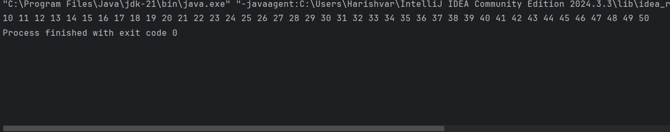

Using While Loop

public class Task1B {  
 public static void main(String[] args) {  
 int i = 10;  
 while(i <= 50){  
 System.*out*.print(i + " ");  
 i++;  
 }  
 }  
}

Output:

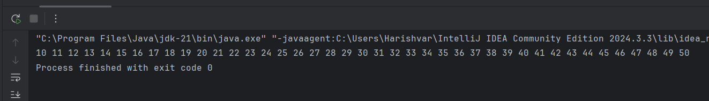

2)Write a program to find whether the given number is positive or negative .

import java.util.\*;  
  
public class PosOrNeg {  
 public static void main(String[] args) {  
 Scanner sc = new Scanner(System.*in*);  
 System.*out*.println("Enter the input to check whether the given input is pos or negative:");  
 int i = sc.nextInt(); //Getting input From the user.  
 if(i < 0){ // checking for negative number.  
 System.*out*.println("The given input is negative.");  
 }  
 else{ // This is for printing the output if the given number is positive.  
 System.*out*.print("The given input is positive number.");  
 }  
 }  
}

Output:

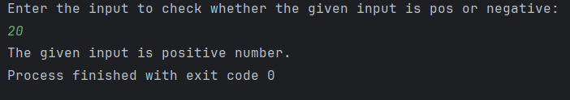

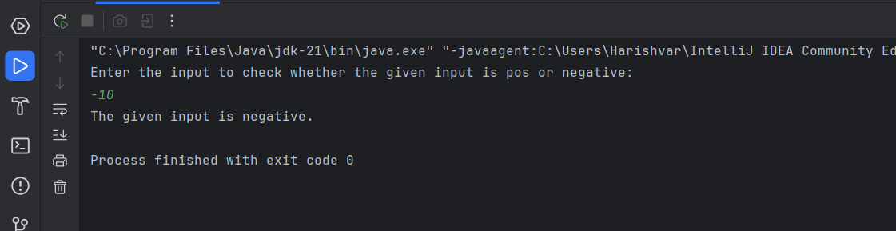

3)

Write down the program to reverse the given number using loops.

import java.util.\*;  
  
  
public class ReverseaNumber {  
 public static void main(String[] args) {  
 Scanner sc = new Scanner(System.*in*);  
 System.*out*.println("Enter The number Reverse :");  
 int number = sc.nextInt();  
 int rev = 0;  
 int rem = 0;  
 while(number > 0){ // Check for the condition whether the number is always > 0 to find the last digit in a number.  
 rem = number % 10;  
 rev =(rev \* 10) + rem;  
 number = number / 10;  
 }  
 System.*out*.print("The Reverse Of the given number is :"+ rev);  
 }  
}

Output:

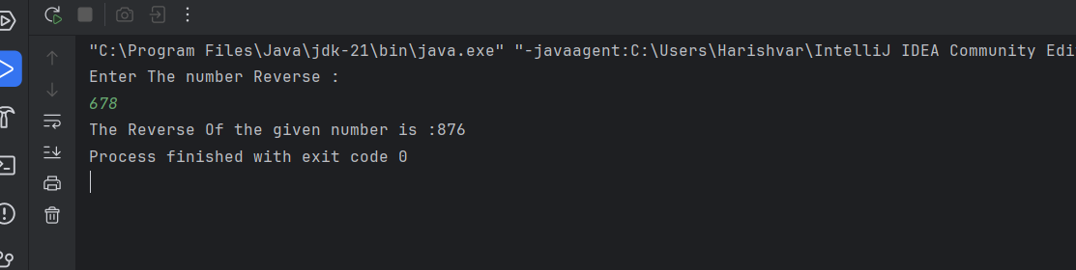

4)Write a java program to find the smallest among three numbers.

Program :

import java.util.\*;  
public class Small {  
 public static void main(String[] args) {  
 Scanner sc = new Scanner(System.*in*);  
 System.*out*.println("Enter the 1 Number:");  
 int num1 = sc.nextInt();  
 System.*out*.println("Enter the 2 Number:");  
 int num2 = sc.nextInt();  
 System.*out*.println("Enter the 3 Number:");  
 int num3 = sc.nextInt();  
  
 if(num1 < num2 && num1 < num3 ){  
 System.*out*.println("The Smallest is "+ num1);  
 }  
 else if(num2 < num1 && num2 < num3){  
 System.*out*.println("The Smallest is "+ num2);  
  
 }  
 else{  
 System.*out*.println("The Smallest is "+ num3);  
 }  
  
  
  
 }  
}

Output:

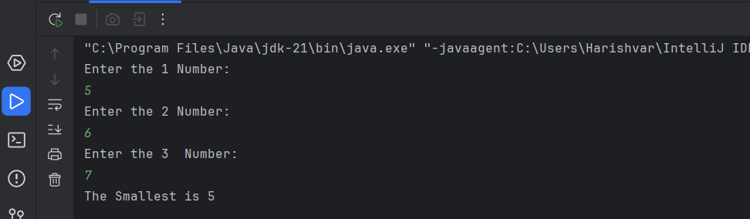

5) Write a Java program that takes the purchase amount as input and calculates the final payable amount after applying the discount.

1. If the purchase amount is less than 500, no discount is applied.

2. If the purchase amount is between 500 and 1000, a 10% discount is applied.

3. If the purchase amount is greater than 1000 a 20% discount is applied.

Program:

import java.util.\*;  
  
public class Discount {  
 public static void main(String[] args) {  
 Scanner sc = new Scanner(System.*in*);  
 System.*out*.println("Enter the Purchase amount:");  
 int purchaseAmount = sc.nextInt();  
 double finalPrice;  
 if(purchaseAmount < 500 ){  
 finalPrice = purchaseAmount;  
 System.*out*.println(finalPrice);  
 }else if(purchaseAmount >= 500 && purchaseAmount <= 1000){  
 finalPrice= purchaseAmount-(purchaseAmount \* 0.1);  
 }  
 else{  
 finalPrice= purchaseAmount-(purchaseAmount \* 0.2);  
 }  
 System.*out*.println("The Price After Discount is :"+ finalPrice);  
  
 }  
}

Output:

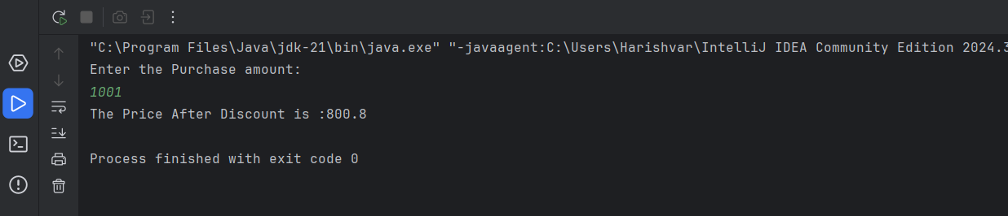

6) Write a java program to print bellowed pattern ->i and j and k=>5

Program:

import java.util.Scanner;  
  
import java.util.Scanner;  
public class Pattern1 {  
 public static void main(String[] args) {  
 Scanner sc = new Scanner(System.*in*);  
 int n = sc.nextInt();  
 for(int i = 0;i < 5; i++) {  
 for (int j = 0; j < 5; j++) {  
 if (i >= j) {  
 System.*out*.print(n - j);  
 } else {  
 System.*out*.print(n - i);  
 }  
  
 }  
 System.*out*.println();  
 }  
 }  
  
}

Output: ss